Name: Irene Komal P

USN: 1BM17IS033

Class: 7A

**Program 1 – WiMax**

* **Set up**

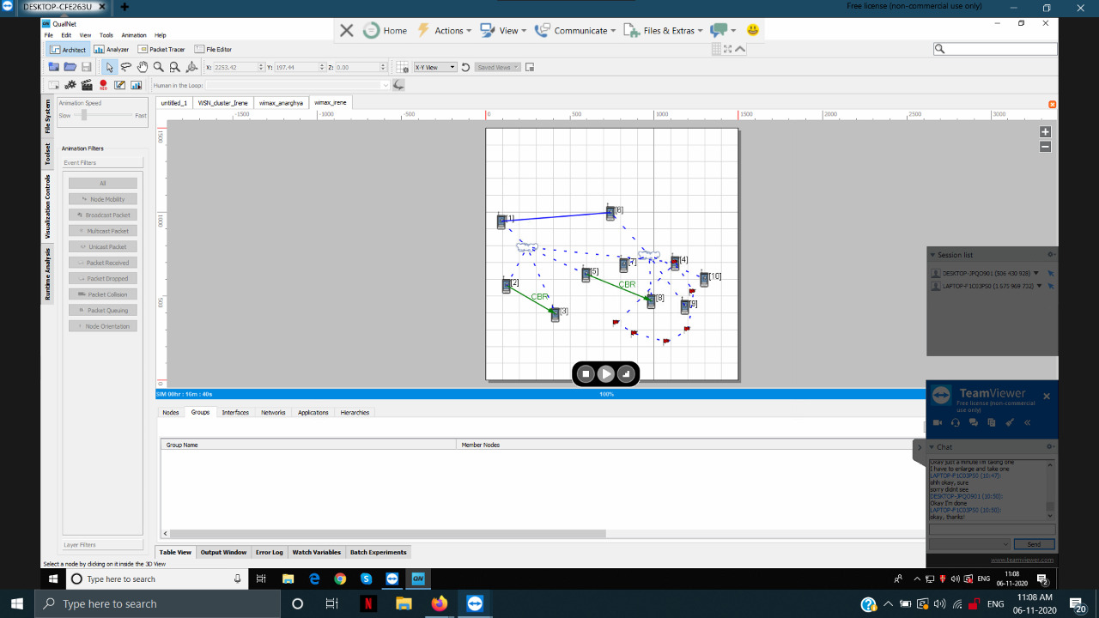

* **Result**

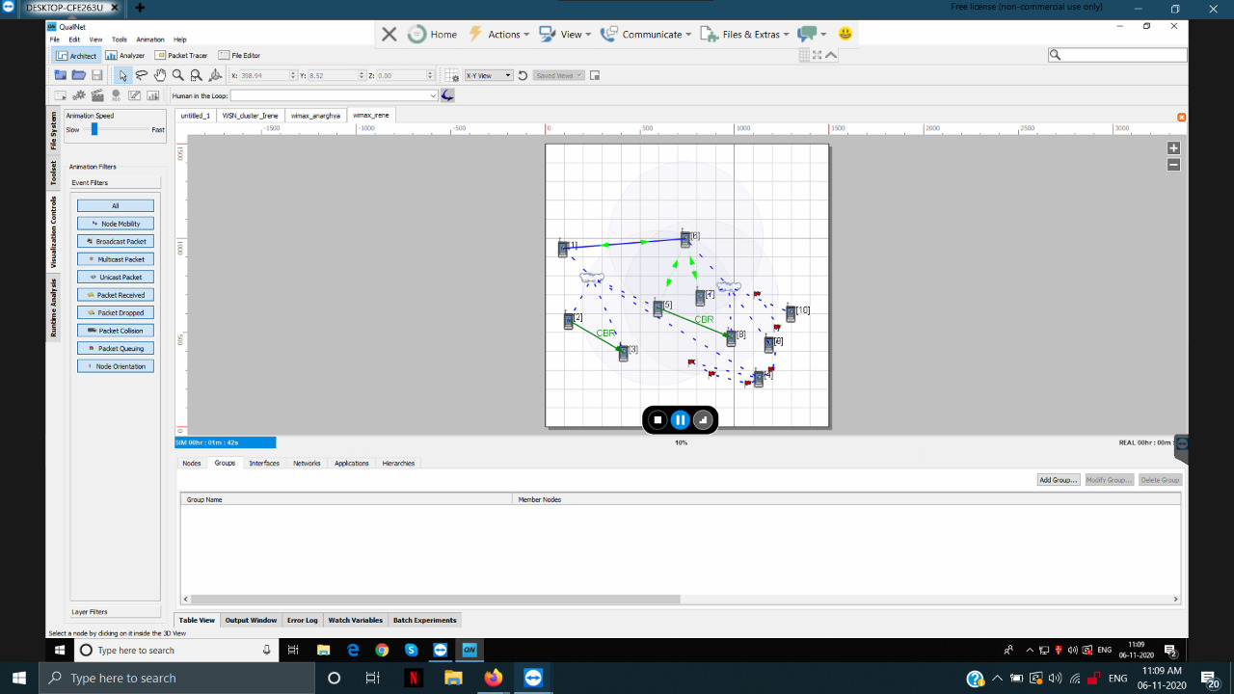

**Program 2 - WSN Clusters**

* **Setup**

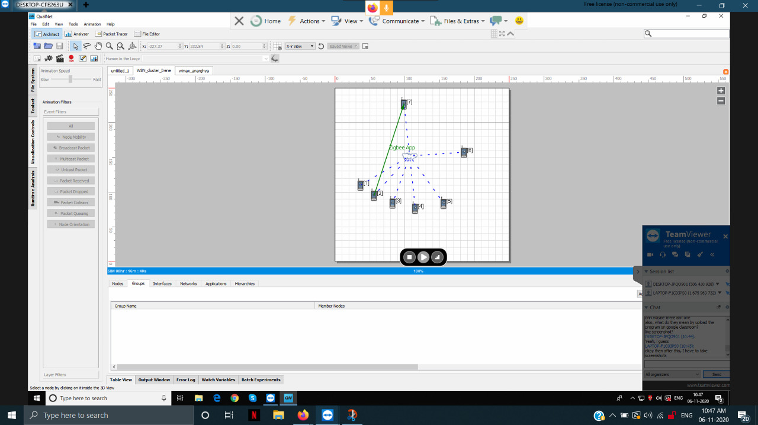

* **Result**

